2025

Mini 4-H

(4-H for 1st and 2nd graders)



# Cass County



It is the policy of the Purdue University Cooperative Extension Service that all persons have equal opportunity and access to its educational

programs, services, activities, and facilities without regard to race, religion, color, sex, age, national origin or ancestry, marital status, parental status, sexual orientation, disability or status as a veteran.

Purdue University is an Affirmative Action institution.

This material may be available in alternative formats.

Purdue/Cass County Extension Service

Cass County Government Building

200 Court Park, Room 302

Logansport, IN 46947-3149

574-753-7750

Email address: cassces@purdue.edu

Our web address: [www.extension.purdue.edu/cass](http://www.extension.purdue.edu/cass)

4-H Online Enrollment address: [http://v2.4honline.com](http://v2.4honline.com/)

Revised 01/2025

**Welcome to Mini 4-H!**

**What is it about? Who can join? What can you do?**

Mini 4-H is learning what 4-H is all about. Mini 4-H is exhibiting a project at the Cass County 4-H Fair. It is fun, it is learning, it is doing and feeling GREAT about doing it.

**MORE…**

* First, you must be in First or Second grade at the time of enrollment and enrolled in Mini 4-H through the 4-H Online enrollment website or on a paper enrollment form. Projects range from Arts and Crafts to Wildlife and include livestock projects. (All Mini 4-Her's not participating in a livestock project will exhibit a simple, yet fun to learn project that will be exhibited in the 4-H Community Center during the fair.)

* The *4-H enrollment period* (online or paper form) begins October 1 each year. We encourage each Mini 4-H member to join a 4-H club. (If you are not familiar with the 4-H clubs in your area, please call the Extension Office for more information.) After that, your 4-H Club Leader will bring your Mini 4-H project manuals to your 4-H club meeting. Contact your 4-H Club Leader to find out when and where the club’s meetings are located.

* If you are interested in showing an animal project, you can do that too. Mini 4-H livestock members MUST show a regular Cass County 4-H club member’s animal; exceptions are the cat, llama, and rabbit projects. Ideally the 4-H member would involve them with the project as much as possible. Local leaders are encouraged to assist Mini members in finding families and 4-Her's willing to share their animal project. Mini 4-Her's are not eligible to sell an animal in the county 4-H auction and are not eligible to show in the Indiana State Fair 4-H Classes.

* To complete your Mini 4-H project you must complete the appropriate record sheet and turn it in with your project the Saturday designated in the handbook at the 4-H Community Center from 7:30-9 a.m. Mini 4-H livestock members are to turn in their record sheets to the appropriate livestock committee when the species checks in at the fair or the Extension Office ahead of the fair. These record sheets are with your Mini 4-H manual.

* Mini 4-Her's are a part of the 4-H program and we welcome you to attend a local 4-H meeting and local or county workshops. Cass County has an annual event especially for 2nd grade Mini 4-H members. Be sure to watch for the date on our Mini 4-H Day Camp!

* You may check with your local leader to find out more about special dates, times and rules. The

Extension Office is also available to answer your questions between the hours of 8 a.m. and 4 p.m., Monday – Friday; just give us a call at 574-753-7750. An answering machine is available after hours.

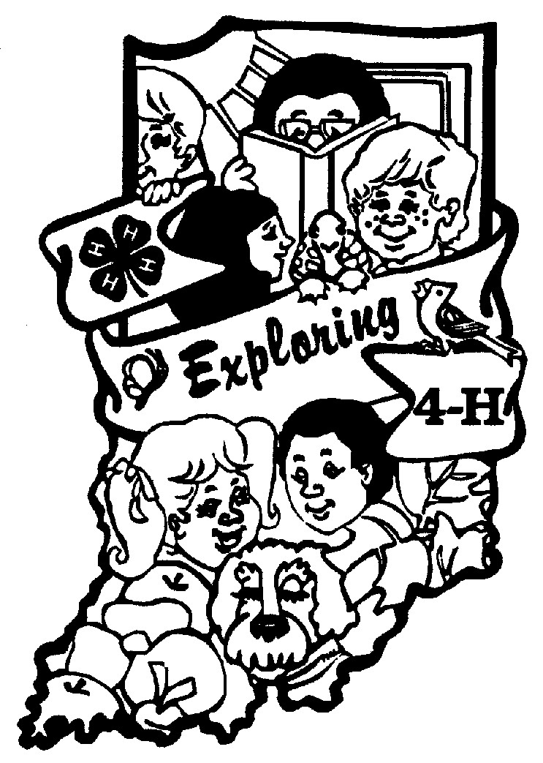

**MINI 4-H - BUILDING PROJECTS:**

* Each of these projects may have several activities (optional) to do in the manual, and a list of exhibits (item you will make and take to the fair) to choose from. Pick ***one*** exhibit you plan to exhibit at the fair. (If you choose the same project for more than one year, choose a different item to exhibit each year.)
* More details about these projects are found in the corresponding Mini 4-H manuals. You will receive these project manuals from your 4-H Leader.
* *REMINDER* – for poster exhibits – size is 11” x 14” displayed horizontally. *Foam core poster boards and plastic covering are available for purchase at the Extension Office.*

**COLLECTIONS:** (Choose one to exhibit)

* Collect and exhibit 5 items or 5 pairs of items. These articles can be rocks, coins, insects, salt and pepper shakers, pencils, or any kind of fun collection. Attach a 3x5-inch card that tells what you collected and why you collected the items.
* If you take Collections more than one year, add 5 more articles to your collection next year.
* Go to a museum and look around at the collections of things. Write a short report on your visit. Display this in a notebook. Here are some things that you might want to put in your report:
  + - Why do museums collect articles? List some things they collect.
    - Ask someone who works at a museum how they get things for their collections.
    - What is the best collection of items? What is the most unusual? (If a museum is not in your home area, try the library.)
* 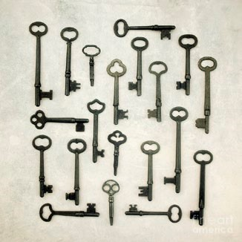Talk to family and friends. Ask them what they like to collect and why they like to collect it. Then make a chart to show your information. Display this in a notebook.

**CRAFTS:**

* Choose **(one)** to exhibit.
  1. Spatter Painting
  2. Decoupage
  3. 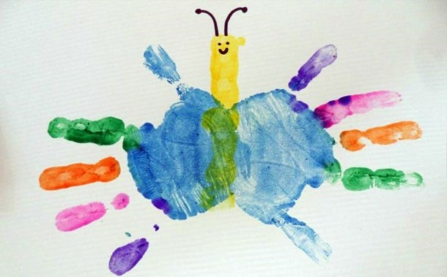Hand Print
  4. Drawing
  5. Gift Bag
  6. Sculpting with Modeling Dough
  7. Sponge Fun
  8. Your Creative Craft (Do your own craft)
  9. Craft Kits
  10. Handmade Paper

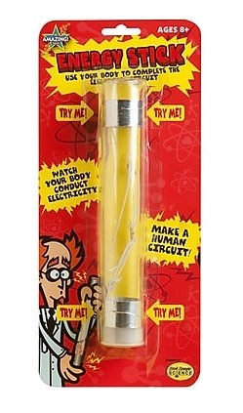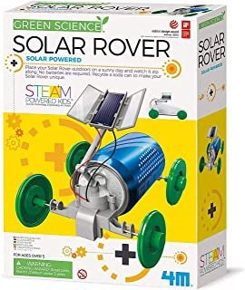

**ELECTRICS:** (Choose one to exhibit)

* First Grade - Energy Stick (kit) - $9 .00
* Second Grade - Solar Rover (kit) - $21.00
* Or any activity page from your manual  *Kits can be purchased at the Extension Office.*

**FARM ANIMALS:** (Poster, notebook or model ONLY) Not a showring exhibit. Enroll in an individual Mini 4-H livestock project to show an animal at the fair.

(Choose one to exhibit)

* Make a poster showing the different things that we get from farm animals. (Examples: hamburgers, wool, eggs, etc.)
* Make a poster showing the different kinds of farm animals. You can use the pictures from Activity 1 or use other pictures that you find.
* Write a story about your favorite farm animal and display it in a notebook.
* Make a model of your favorite farm animal. If you want, add it to the farm scene you made in the shoebox (see Activity 4).
* Make a poster of your favorite farm animal and identify 5 parts of the animal.
* Talk to a farmer. Ask him or her questions about working on a farm. What animals does he/she raise, and what do they feed their animals? Write a story about the farmer. Display in a notebook.
* Write or rewrite your favorite fairy tale using farm animals. (For example: Cinderella on the Farm) Display in a notebook.
* 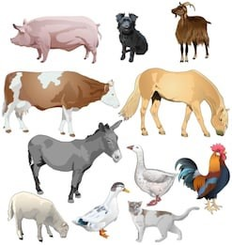Make a poster of your favorite farm animal and identify 10 parts of the animal. Use a different animal than you did last year.
* Anything else you can think of. Be creative!

**FLOWERS AND PLANTS:** (Choose one to exhibit)

* 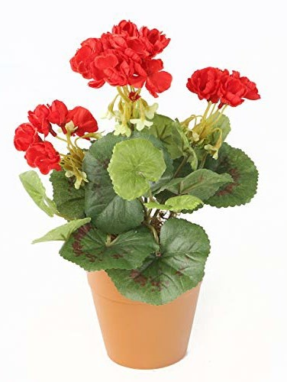Three cut flowers in a vase. The flowers can be the same kind or different kinds. Attach a small label that tells the kind of flower.
* A flowering plant in a pot. Attach a small label that tells the kind of flowering plant.
* A houseplant. Attach a small label that tells the kind of plant.
* A cactus. Attach a small label that tells the kind of cactus.
* Exhibit a colored flower. See Activity 6 for directions.
* Make a poster that shows the different parts of a plant.
* Find at least 3 pictures of flowers. Write the names of the flowers next to their pictures. You can use the flowers in the manual. Put the pictures in a self-made notebook.

**FOODS:** (Choose one to exhibit)

* Popcorn or another snack mix displayed in a small plastic sandwich bag
* Two no-bake cookies displayed in a small plastic sandwich bag• A poster you made that shows at least three kitchen safety rules

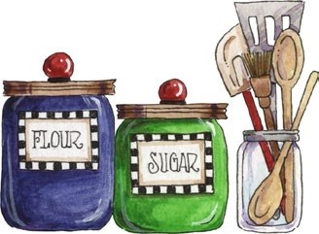

* A poster you made that shows MyPlate.
* Two marshmallow bars (rice crispy treat, etc.) displayed in a small plastic sandwich bag
* A poster you made that shows how to properly measure ingredients• Your 4-H Cooking Kit

**MODELS:** (Choose one to exhibit)

* Make one snap-together plastic model. Do not glue or paint your model.
* Make a model using 2 to 4 different items of your choice. Examples: clay, toothpicks, sticks, ceramics, sugar cubes, etc.
* Visit a museum and look around at different models. Write a short report on your visit. Here are some things you might want to put in your report:
  + 1. *What kind of models did you see?*
    2. *Ask someone who works at the museum how they build their models. Or do they buy the models already built?*
    3. *What was your favorite model? Why did you like this model? How big was it? How big would the real-life item be?*
* Make a model using as many different items of your choice. Make a model background to display your model. Example: Paint a shoebox so that a plastic model car looks like it is driving down the road, across a field, through the water or the air.

**LEGO® MODELS:** (Choose one to exhibit)

* Make a model using any type of Legos. Keep it simple and no larger than 10” X 10”. Please Note: The use of the word “Lego” is used only as a guide for the project. You are free to use any brand of plastic snap-together or connecting pieces to complete your project.

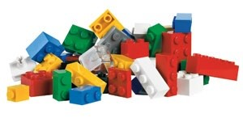 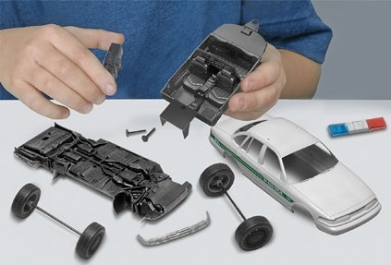

**READING:** (choose one to exhibit)

* Draw a picture of your favorite book character. Display this on a poster.
* Create a model or diorama of a scene from your favorite book.
* Write a short book report about your favorite book. List the name of the book and the author. Display in a notebook or on a poster.
* Design a new book cover for your favorite book. Display on a poster
* Create a paper bag book report. Decorate a paper bag to show your favorite book, then fill it with 5 items to represent characters or what happens in the book.
* Make a map of your library, to help others find their way around. Display this on a poster.
* Make a poster about your book.

There are lots of ideas on the Internet. Be creative and use your imagination!



**ROBOTICS:** (Choose one to exhibit)

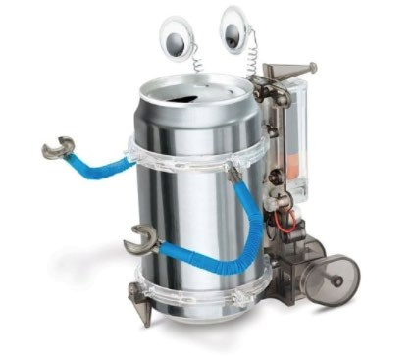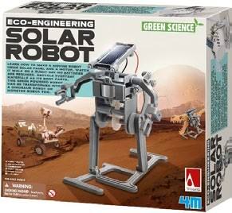

* 1st Grade - Tin Can Robot (kit) - $12.00
* 2nd Grade - Solar Robot (kit) - $19.00
* Or any activity page from your manual

*Kits can be purchased at the Extension Office.*

**SEWING:** (Choose one to exhibit)

* Sewing Kit
* Pin Cushion
* Tissue Box Cover
* Placemat
* Cooking/BBQ Apron

**SUN, STARS, & SPACE:** (Choose one to exhibit)

* 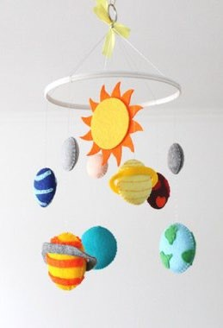Make a solar system mobile. You may use any materials that you want. Make sure that you label each planet.
* Exhibit the asteroid you made in Activity 2.
* Exhibit the comet you made in Activity 3.
* Make a model or poster of the shuttle. Label the main parts of the shuttle.
* Make a poster showing one or two different constellations. You can use the ones in this manual or find new ones.
* Make a poster about one or two different planets. Label the planets and tell something about them. You can use the information in this manual or find your own.
* Make a poster about your own make-believe planet. Be creative. If you were going to visit this planet, what would you find?

**TOY FARM SCENE / DOLLHOUSE DIORAMA:** (Choose one to exhibit)

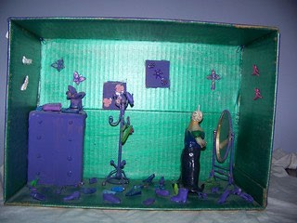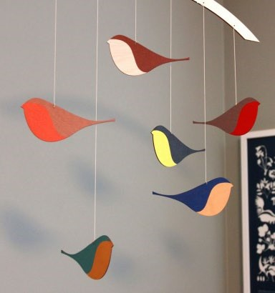

* Toy Farm Diorama – Exhibit a diorama, no bigger than a 10”X16” shoebox. You can highlight a farm theme with animals, shelter, food, crops, equipment, etc.
* Dollhouse Diorama – Exhibit a diorama, no bigger than a 10”X16” shoebox. You can include 1-2 rooms of household items including furniture, appliances, décor and accessories, etc.

**WILDLIFE:** (Choose one to exhibit)

* Birds Poster (from Activity 1)
* Birds Mobile (from Activity 1)
* Bird Feeder (from Activity 2)
* Bird Watching Chart Poster (from Activity 3)
* Paper Airplane (from Activity 4)
* Three Insects (from Activity 5)
* Local Wildlife Poster (from Activity 6)

**MINI 4-H (Grades 1st & 2nd) - LIVESTOCK PROJECTS:**

***Mini livestock projects are exhibited as a special (non-placings) class in their respective specie's show.***

***(Animal projects: Beef, Cat, Dairy, Dog, Goat, Horse & Pony, Llama, Poultry, Rabbit, Sheep, and Swine.)***

* SEE 4-H MINI LIVESTOCK MANUALS FOR SPECIFIC EXHIBIT REQUIREMENTS.
* Mini 4-H Livestock project members must show a regular Cass County 4-H club members' animal except for Cat, Llama and Rabbit. Mini 4-H’ers can show their own Cat, Llama, and Rabbit. Mini 4-H Dog members do not show a dog but attend dog trainings, observe training techniques and assist.
* If you want to show an animal at the fair, sign up for each animal livestock project you want to show. (Limit 4 total projects in Mini 4-H)
* See “Safety Policy” and form to sign on the back of the Mini 4-H enrollment form.
* Mini 4-Her's must turn in appropriate completed livestock record sheet (from their manual) to the committee when the species is checked in at the fair.
* If you want to learn about animals, but not show an animal, complete a poster about the animal chosen. All Mini 4-H animal (livestock) posters will be placed in the Farm Animals project. These poster projects and record sheets are due on the Saturday designated in the handbook between 7:30-9a.m.

2025 CASS COUNTY - MINI 4-H (1st and 2nd grade) ENROLLMENT FORM

**Return this form to the Cass County Extension Office, or enroll online at:**  [**http://v2.4honline.com**](http://v2.4honline.com/)

Purdue University Cooperative Extension is an equal access/equal opportunity institution.

## PURDUE/CASS COUNTY EXTENSION OFFICE, 200 COURT PARK, ROOM 302, LOGANSPORT, IN 46947 574-753-7750

**(All information must be filled in or enrollment will NOT be considered complete!)**

**FAMILY NAME______________________________________________ FAMILY EMAIL_________________________________**

**LAST NAME**__________________________ **FIRST NAME**________________________**MIDDLE NAME/INITIAL**_____________

**PREFERRED NAME**_____________ **COUNTY OF RESIDENCE** ____________________________

**MAILING ADDRESS** ____________________________________ **CITY**__________________ **STATE** _______ **ZIP** ___________ **BIRTHDATE** (mm/dd/yyyy)**:** _____________________________ **GENDER: MALE** □ **FEMALE** □

**PRIMARY PHONE** ( ) _____-_________ **CELL** ( ) _____-_________ **EMAIL (if different than family email)**: ____________

**I WOULD LIKE TO RECEIVE TEXT MESSAGES** □ **CORRESPONDENCE PREFERENCE: POSTAL MAIL** □ **EMAIL** □ **CELL PHONE PROVIDER (if you want to receive text messages) ________________________________________**

**PARENT/GUARDIAN 1:**

FIRST NAME_________________________________________ LAST NAME_______________________________________

MAILING ADDRESS ____________________________________________ EMAIL____________________________

PHONE ( ) ______-_________WORK ( ) ______-______________ CELL ( ) ______-__________ **PARENT/GUARDIAN 2:**

FIRST NAME________________________________________ LAST NAME________________________________________

MAILING ADDRESS ____________________________________________ EMAIL____________________________

PHONE ( ) ______-_________WORK ( ) ______-______________ CELL ( ) ______-__________

**SECOND HOUSEHOLD: Send Correspondence? Yes** □ **No** □ **Correspondence Preference: Mail** □ **Email** □

**SECOND HOUSEHOLD FAMILY LAST NAME______________________________ PRIMARY PHONE** ( ) _____-_________

**MAILING ADDRESS** ____________________________________ **CITY**__________________ **STATE** _______ **ZIP** ___________ **EMAIL___________________________________________________________________________________________________**

**EMERGENCY CONTACT:** NAME______________________________________ RELATIONSHIP ______________________

PHONE ( ) ______-______________ CELL ( ) ______-_______________

**ETHNICITY:** Are you of Hispanic ethnicity? □ No □ Yes

**RACE (circle all that apply)**: White, Black, Native Indian/Alaska Native, Native Hawaiian/Pacific Islander, Asian, Prefer Not to State

**RESIDENCE:** □ Farm □ Town under 10,000 and non-farm □ Town/City 10,000-50,000 and its suburbs

□ Suburb of city more than 50,000 □ Central City more than 50,000

**MILITARY:** □ No one in my family is serving in the military □ I have a parent serving in the military □ I have a sibling serving in the military

**Branch:** □ Air Force □ Army □ DOD Civilian □ Marines □ Navy

**Component:** □ Active Duty □ National Guard □ Reserves

**SCHOOL:** ________________________________________ **SCHOOL COUNTY:** ____________ **GRADE** (as of 10-1-24)**:** ______

**NUMBER OF YEARS IN 4-H (including this year):** _________ **4-H CLUB:** ___________________________________________

**SCHOOL TYPE** (circle one): Public, Private, Special Ed., Vocational, Homeschool/Alternative, Magnet/Specialized School, Charter School

**MINI 4-H PROJECTS: (Maximum Enrollment - 4 projects)**

|  |  |  |  |
| --- | --- | --- | --- |
| ____ Collections  ____ Crafts  ____ Electric  ____ Farm Animals  ____ Flowers and Plants  ____ Foods  ____ Legos® | ____ Models  ____ Robotics  ____ Reading  ____ Sewing  ____ Sun, Stars & Space  ____ Toy Farm/Dollhouse  Diorama | ____ Wildlife  ____ Beef  ____ Cat  ____ Dairy  ____ Dog  ____ Goat | ____ Horse & Pony  ____ Llama  ____ Poultry  ____ Rabbit  ____ Sheep  ____ Swine |

## 4-H Youth Development Liability Release

I understand that participating in 4-H activities can involve certain risks to my child. Those risks may include injury or harm, including, but not limited to, bodily injury, disability, exposure to COVID-19 and other viruses and or illnesses, and death. During virtual 4-H activities, I understand that program staff are not providing supervision for my child during the online program, and the Released Parties do not have control over the information available through the internet or other electronic data sources beyond that which is a part of the 4-H activity. On behalf of my child, I fully assume the inherent risks associated with my child participating in 4-H activities and assert that my child has chosen to participate in this program with my express approval. I hereby release and discharge Purdue University, The Trustees of Purdue University, the Cass County

Commissioners, the Cass County Cooperative Extension Service, and each of their trustees, officers, appointees, agents, employees, and volunteers ("Released Parties") from all claims which my child or I might have for any injury or harm to my child, arising out of my child’s participation in any activity related to the 4-H program, even if such injury or harm is caused by the negligence or fault of any of the Released Parties. I do not, however, release these individuals and entities from liability for intentional, willful or wanton acts and this release shall not be construed to include such acts. **□By checking this box and signing this form, we have read and agree to the terms.**

## Parent/Legal Guardian Statement

I (we) understand, agree to abide by, follow, and comply with the rules, policies and expectations of the 4-H program and will conduct myself (ourselves) in a courteous and respectful manner by exhibiting good sportsmanship and being a positive role model for youth. I (we) also understand that failing to do so will constitute grounds for sanctions against and/or dismissal of me (us) and/or the member from the program. **□By checking this box and signing this form, we have read and agree to the terms.**

## Photo Policy Statement

By participating in Indiana 4-H, I grant permission to the Indiana 4-H Youth Development Program to use videos or photographs of me (my child) for educational purposes or promotion of 4-H and/or Purdue Extension programs. For questions, or to decline this condition, please contact the County Extension Office.

**□By checking this box and signing this form, I agree to the photo policy statement**

## See Back for Required Signatures

**Mini 4-H Liability Release Form**

Safety Policy for Mini 4-H Members Showing Animals

**(Cass County – 1st and 2nd graders)**

The safety and well-being of our 4-H youth is of the utmost importance. Although kindergarten is specified as the time when a child may begin participation in some 4-H events and activities, parents are encouraged to take into consideration their child’s physical and mental development before agreeing to let the child begin to show, work with, or care for animals. **(Only 1st and 2nd graders may exhibit animals in Cass County)** Each child matures at a different rate, and children in grades K-2 may still be too young to begin showing, working with, or caring for animals.

The Indiana 4-H Youth Development Program at Purdue University has agreed to allow Mini 4Hmembers in grades K-2, to participate in NON-COMPETITIVE animal projects subject to certain conditions. **Cass County has 4-H Exhibition for members in 1st and 2nd grades.** These conditions are specified below.

“Mini 4-H members, in grades K through 2, will be allowed to show, work with, or care for animal projects after their parent or legal guardian has signed a liability release. Mini 4-H members may independently show, work with, or care for animals that weigh 300 pounds or less. Mini 4-H members may only show, work with, or care for animals over 300 pounds when they are assisted by a parent, legal guardian, or another adult designated in writing by parent or legal guardian.” (The word assisted means that the adult has control of the animal at all times.) Mini 4-H members are not required to own the animals they participate with in Mini 4-H.

All animals on exhibit should meet the regulations of the Indiana Board of Animal Health Requirements for Exhibition of Domestic Animals in Indiana and meet the vaccination requirements set by Indiana 4-H.

Mini 4-H members exhibiting horses must wear ASTM or SEI standard F1163 (or above) certified helmets whenever mounted. The parent/guardian is responsible to see that this specified headgear is properly fitted with the approved harness in place and fastened whenever a rider is mounted.

I understand that participating in 4-H activities can involve certain risks to my child. Those risks may include injury or harm, including, but not limited to, bodily injury, disability, exposure to COVID-19and other viruses and or illnesses, and death. During virtual 4-H activities, I understand that program staff are not providing supervision for my child during the online program, and the Released Parties do not have control over the information available through the internet or other electronic data sources beyond that which is a part of the 4-H activity. On behalf of my child, I fully assume the inherent risks associated with my child participating in 4H activities and assert that my child has chosen to participate in this program with my express approval. I hereby release and discharge Purdue University, The Trustees of Purdue

University, the Cass County Commissioners, the Cass County Cooperative Extension Service, and each of their trustees, officers, appointees, agents, employees, and volunteers ("Released Parties") from all claims which my child or I might have for any injury or harm to my child, arising out of my child’s participation in any activity related to the 4-H program, even if such injury or harm is caused by the negligence or fault of any of the Released Parties. I do not, however, release these individuals and entities from liability for intentional, willful or wanton acts and this release shall not be construed to include such acts

__________________________________

Mini 4-H member’s name

________________________________

Other Adult Designee - Print Name

__________________________________ __________________

Signature of Parent/Legal Guardian Date

_________________________________ __________________

Signature of Parent/Legal Guardian Date

**Indiana 4-H Behavioral Criteria for all Youth Participants**

Indiana 4-H has a set of behavioral criteria that we expect our participants to follow as outlined below.

Youth and their parents/guardians review and agree to these expectations at the time of 4-H enrollment in 4-H Online. When attending, participating in, or acting on behalf of the 4-H program, all persons are expected to conduct themselves in accordance with accepted standards of social behavior, to respect rights of others, and to refrain from any conduct which may be injurious to the 4-H program to persons and the 4-H program.

As a participant in the Indiana 4-H Youth Development Program, I will:

* Respect, follow, and enforce the rules, policies, and guidelines established by the Purdue University Cooperative Extension Service, including all laws related to child abuse and substance abuse.
* Conduct myself in a courteous, respectful manner, exhibit good sportsmanship, and demonstrate reasonable conflict management skills. I will avoid any action that would obstruct or disrupt any 4-H activity, or that threatens or interferes with maintenance of appropriate order and discipline, and will also discourage others from any of those actions.
* Be truthful and forthright when representing the 4-H Youth Development Program. At no time, will I cheat or knowingly furnish false information.
* Present accurate, unaltered 4-H records.
* Follow the specific terms and conditions of a given project, contest, or activity. I will also encourage others to follow these terms and conditions.
* Under no circumstances possess, distribute, consume, or be under the influence of alcohol, tobacco or tobacco-like products, electronic smoking devices (including, but not limited to, e-cigs, vapes, Juuls), illegal drugs, or other dangerous substances at 4-H Youth Development Program events or activities.
* Under no circumstances distribute, misuse, or abuse over-the-counter, homeopathic (including supplements and vitamins), or prescription medications.
* Under no circumstances possess or use weapons, fire crackers, chemicals, or other materials that can be used to create an explosive mixture. Note: firearms and archery equipment utilized under the direct supervision of an approved and certified 4-H Shooting Sports Instructor at an approved 4-H Shooting Sports activity are acceptable.
* Recognize that verbal, physical, or emotional abuse, or any conduct which threatens or endangers the health or safety of any person will not be tolerated. Avoid any reckless or inappropriate behavior.
* Respect physical property of others. Theft of, or malicious damage to, property is not tolerated, nor is any unauthorized entry, use, or occupancy of any facility.
* Understand that failure to comply with equal opportunity and anti-discrimination laws, or committing criminal acts are not acceptable practices in 4-H Youth Development Programs
* Embrace diversity among all youth and adult participants, helping each person to feel welcome and included in the 4-H Youth Development Program.
* Accept my responsibility to represent 4-H Youth Development Programs with dignity and pride by being a positive role model for others.
* Avoid inappropriate interactions with, and inappropriate displays of affection toward, other persons. I will not have unapproved guests in sleeping quarters at overnight 4-H events, nor will I engage in sexual behavior.
* Wear clothing that is appropriate for the event or activity.
* Avoid using any lewd, indecent, or obscene conduct or language.
* Accept supervision and support from Extension staff or designated volunteers.
* Be mindful of and follow Purdue, Centers for Disease Control and Prevention (CDC), and other state and local health authority safety guidelines and procedures related to any epidemic or pandemic illness.
* Participate in appropriate orientation and training, including youth protection standards, sponsored by the Purdue Cooperative Extension Service.
* Operate machinery, vehicles, and other equipment in a safe and responsible manner.
* Not misuse fire equipment or sound a false fire alarm.
* Treat animals in a humane manner and teach program participants appropriate animal care and management.
* Use technology in an appropriate manner that reflects the best practices in youth development. During virtual 4-H activities, I will follow acceptable University practices being mindful of the virtual learning environment.
* Accept my responsibility to promote and support the 4-H Youth Development Program in order to develop an effective county, state, and national program.

I have been given the opportunity to review these expectations and the opportunity to ask questions, and those questions have been answered to my satisfaction. By signing below, I acknowledge that I have read and agree to abide by the behavioral expectations in this document. I understand that my failure to comply with these expectations may result in disciplinary action or termination of my participation in the Indiana 4-H Youth Development Program.

### □By checking this box and signing this form, we have read and completed all required authorization sections above and agree to the terms

____________________________________ ___________________

Print 4-H Member Name Date

_______________________________________ ___________________

4-H Member Signature (required if 18 years of age or over) Date

_______________________________________ ___________________

Parent/Legal Guardian Signature Date

_______________________________________ ___________________

Parent/Legal Guardian Signature Date

**Purdue Extension is an Affirmative Action/Equal Opportunity Institution.**

9